Chapter 12, Problem 86.

For the single-phase three-wire system in Fig. 12.77, find currents I_{aA}, I_{bB}, and I_{nN}.

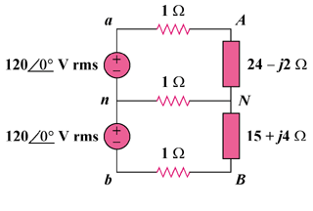

Figure 12.77
For Prob. 12.86.

